IT’SME247 BILL PAY (PAYVERIS)

General Information

Your credit union has launched a new, enhanced, online bill pay. Our new system includes features that make this valuable tool even better, including:
- Full integration within online banking
- Full mobile functionality for your phone or tablet
- Ability to configure email alerts
- Real-time access to checking account balance
- Reminders if balance isn’t sufficient to pay bills
- A more intuitive, user-friendly experience

How do I set Up My Payees?
Our upgraded system is easy to navigate, allowing you to quickly enter payees that should have been recorded on the Payee-Info Collection Sheet prior to February 9th, 2016.
Have you checked out our member tutorial called “Adding a Payee in It’sMe247 Bill Pay?”
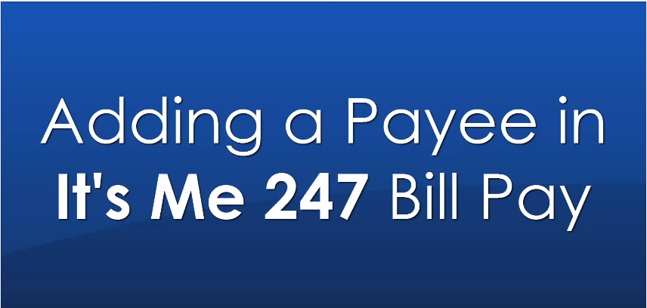

will payments process differently?
IMPORTANT CHANGE – You will no longer select the ‘deliver by’ date when scheduling payments. The new system will ask you what day you want to ‘send’ your payment. Here is an example of the difference:
Previous Method: You would schedule a payment to be delivered by 08/12/16. The bill pay system will then send your payment prior to the payment date so that your payment would arrive by said date.
New Method: You will pick the day that you want your payment to be processed. You will notice that we will display the estimated delivery date for your convenience. If your payment is due by 08/12/16, you would need to login before your due date and schedule your payment.
Electronic Payment – You would need to send on or before 08/11/16.
Check Payment – You would need to send on or before 08/03/16.
Additionally, with the previous bill pay system, your payment could be sent as a member draft check, corporate check, or an electronic payment. The new system will no longer send a corporate check from your account.

Have my Payments PRocessed?
Yes. While you did not have access to bill pay for a short period of time, payments still processed and will continue to process on the old system through February 15th, 2016**. Refer to the Payee-Info Collection Sheet that we recommended completing before February 9th, 2016.
**Additionally, if your payment is scheduled to be delivered on or before February 15th, 2016, your payment will be scheduled to process through the previous bill pay system and you will not see this information on our new It’s Me 247 Bill Pay.
If your payment is scheduled after February 15th, 2016, you will need to log in and reschedule the payment using the new system.

What Happened to my Repeating / Automated PAyments
Repeating or automated payments were not carried over to the new system. If reoccurring payments are scheduled after February 15th, 2016, you will need to reschedule your payments using the new system.

Where IS my Payment History?
Your payment history did not carry over to our new bill pay system, however you should be able to retrieve that information by reviewing your Account Summary within the online banking. If you have a question regarding your payment, you could consider contacting the payee directly to confirm receipt of your payment.

Where are my statements?
Electronic statements (eBills) did not carry over to the new system. If your payee was sending your bill to bill pay, you have automatically been un-enrolled from this service. We now encourage you to login and enroll in the eBill service to re-establish electronic statements.

Wheres the Payment Inquiry Tool?
The payment inquiry tool is no longer be available within bill pay. If you have a question about your payment, you can contact our member service department by giving us a call or stopping by your local branch.

HOW WILL I RECEIVE BILL PAY NOTIFICATIONS?
We have two ways of communication with our enhanced system.
EMAIL NOTIFICATION: You will receive an email notification from our bill pay system. The communication will be sent by noreply@payveris.com. We encourage that you add this email address to your address book to ensure that it is correctly delivered to your inbox.
ONLINE BANKING NOTIFICATION: It’sMe247 will display the same communication within the bill pay message center.

Will I STILL BE ABLE TO transfer money between these accounts?
The Account-to-Account (A2A) feature will no longer be available with the enhancement. If you have added an external account for these transfers, the information will not be carried over to our new system.
We are excited to announce that we will be offering a Person-to-Person (P2P) program. You will have the convenience of sending money to anyone located in the United States by sending a secure text message or email.

What is Person-to-person?
The Person-to-Person program allows you to electronically send money to any individual located in the United States. You will not be asked to enter their account number and routing number. Instead – you will be asked to specify how you wish to send the payment. You will be able to send either a secure text message or email communication. With your transfer, you will enter a password that should be provided to the recipient. They will be sent a secure website that walks them through the steps of collecting the money you sent.

What If I’ve never used Bill Pay?
No worries - We encourage new enrollments at all times!

Bill Pay Key Terms
- ELECTRONIC PAYEE: Merchant allows payments to be processed electronically.
(Processing Time: 1-2 Business Days)
- PAPER CHECK PAYEE: Merchant will receive a physical check in the mail delivered by the United States Postal System (USPS).
(Processing Time: 7 Business Days)
- MANAGED PAYEE: The bill pay vendor and the payee have established a relationship to better deliver payments on behalf of the member. The payment address is not displayed to member because the information is considered proprietary information to the vendor.
- RECURRING PAYMENTS: User-defined request for automatic payments for a specific payee. The member will define the payment amount, frequency, start date, and end date.
- EBILL: Payment (bill) information will display within your Bill pay Dashboard. This information will provide you with the important items such as Payment Date, Amount Due, and Available Balance (if applicable).
Thanks for being our member!

